## Using Social Features in O365

**Lab Time**: 45 minutes

**Lab Folder**: C:\Student\Modules\Social

**Lab Overview:** In this lab you will update your profile, create and manage a blog site, post to your newsfeed on your personal site, create a team site for newsfeeds, and work with OneDrive for Business syncing.

### Exercise 1: Update Your Profile

In this exercise you will learn how to update your profile information such as Basic Information, Contact Information, Personal Details, as well as update Newsfeed settings, and change profile permissions.

#### Log in to SharePoint Online Site

1. Make sure you have the login information for the SharePoint environment where you will work on your lab exercises. You should have received this log in information from the hosting training company or from your instructor.
2. Make sure you have the URL to the **Team Site** that has been created for you to do your lab work. This URL will be in a form that looks something like this.

https://cptclassroom101.sharepoint.com/sites/Student_Teamsite

1. Launch Internet Explorer and navigate to the URL of the Team Site mentioned in the previous step. Note that you should be logged in with a user account that has full control and access to the site collection, and therefore will be permitted access and be able to create lists.
   1. When prompted to login, enter the user name and password that has been supplied to you and then click **OK**.

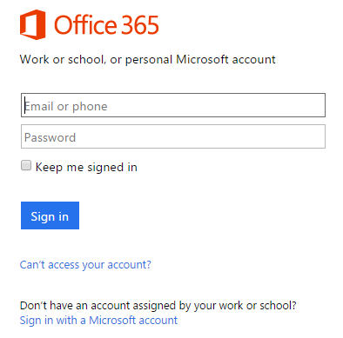

* 1. You should be able to confirm that you are logged into the SharePoint site. For example, if you were logged in as a student named **CPT Student**, your name would appear in the SharePoint Welcome menu as shown in the following screenshot.

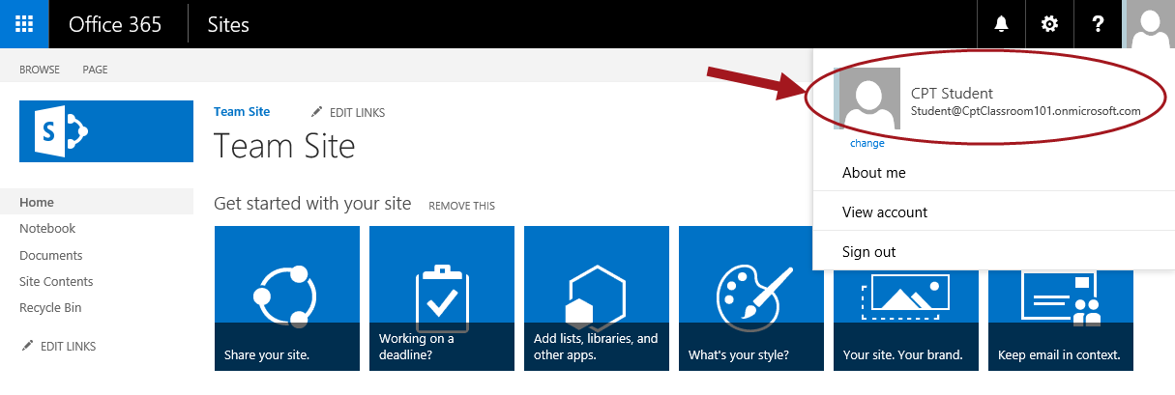

#### Navigating in Delve

1. Click on the logged in user name **CPT Student** select **About Me**.

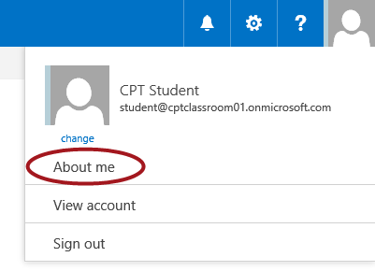

SharePoint will start getting Delve ready for you. Since this process may take a while, proceed with the next steps to get familiar with the other areas.

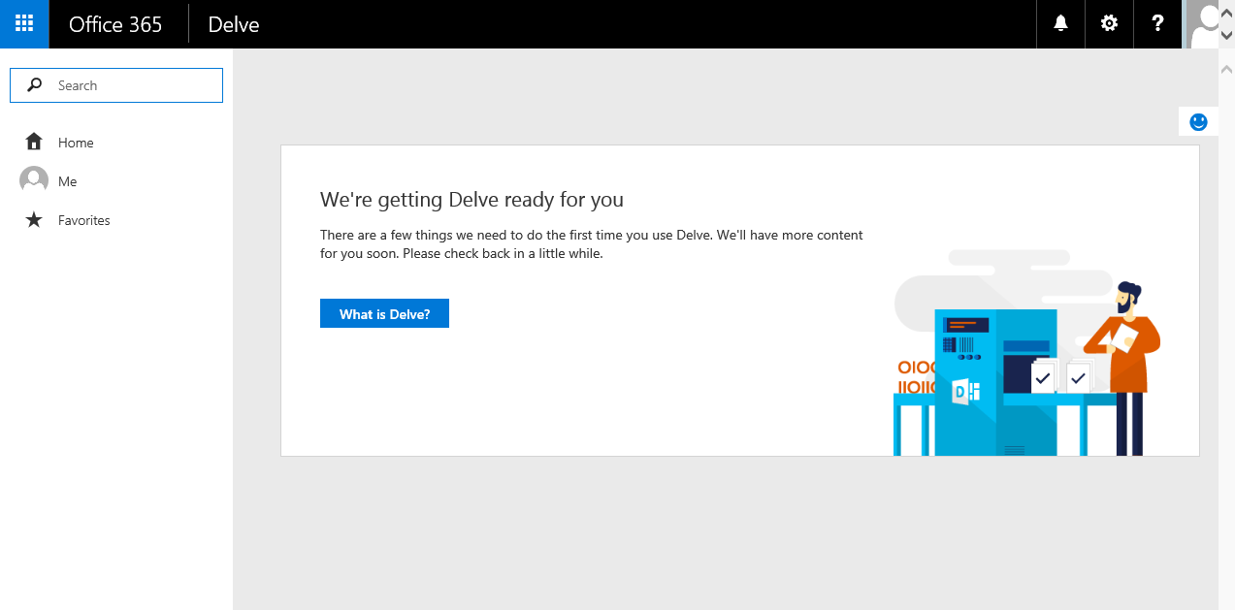

1. In the left navigation click on **Home**.

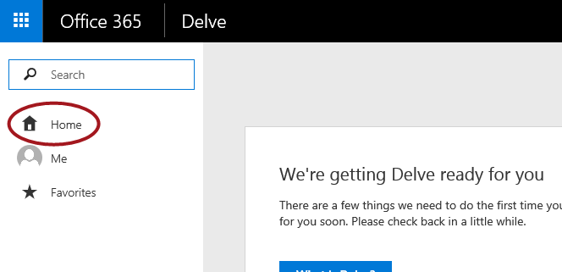

Your Homepage in Delve, shows documents that are likely to be most interesting to you right now. This will give you personalized and up-to-date overview of what you and people around you are currently working on. NOTE: You will only see content you have access to.

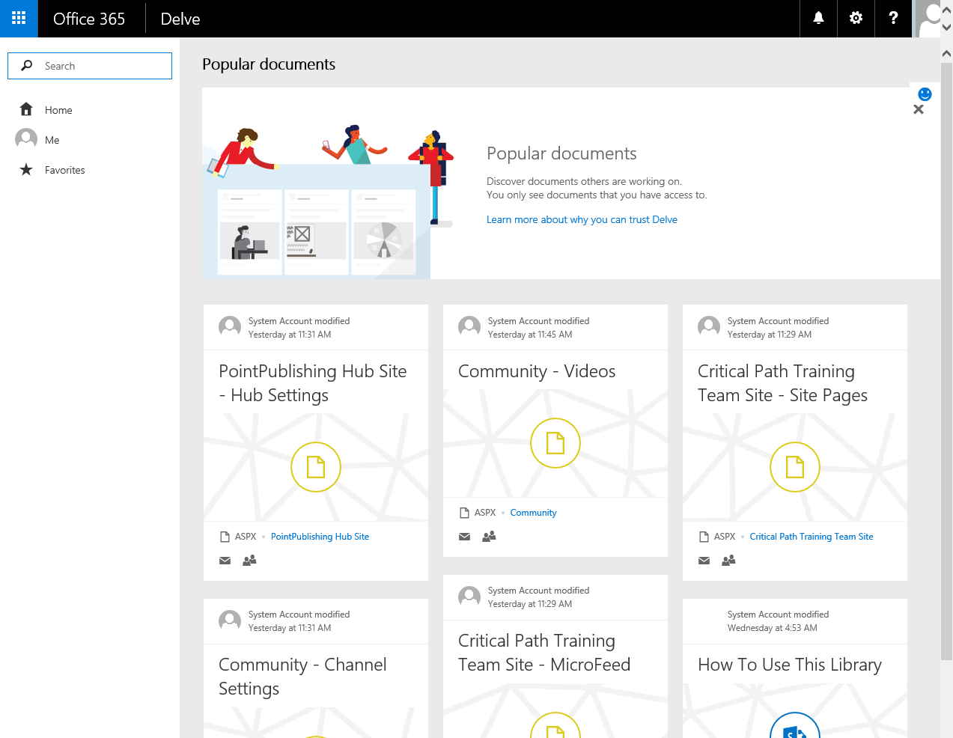

1. To go back to your own documents on your profile page, click on **Me**.

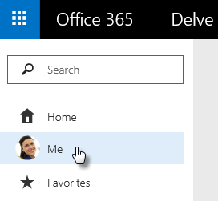

1. The **Get back to your recent documents** section, shows documents you’ve recently authored or modified that are store in SharePoint sites or OneDrive for Business.

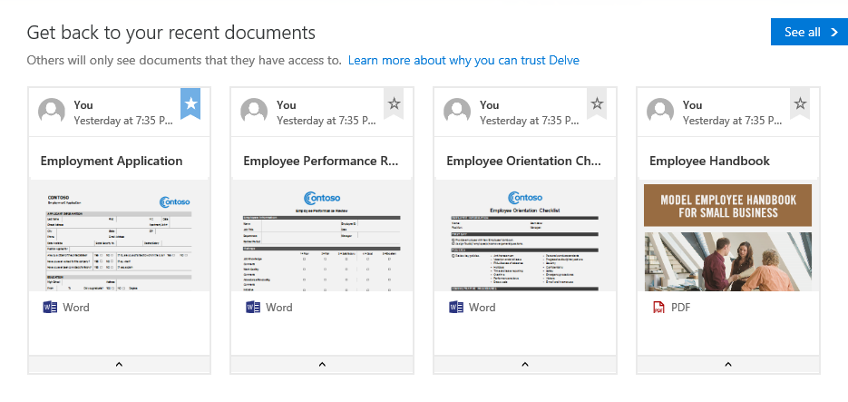

#### Edit Profile Basic Information

1. Click on **Edit profile** under your name.

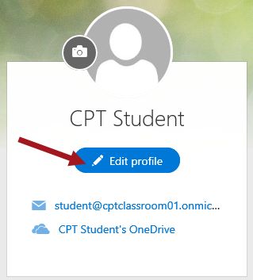

1. From the **Basic Information** panel, place your cursor in the **About me** multi-line text box and type a desired description about yourself.

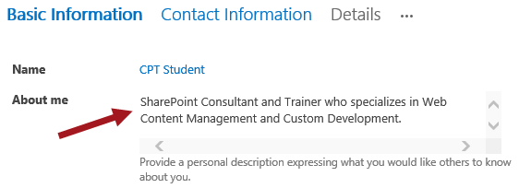

1. Upload a profile picture:
   1. In the **Picture** section, click the **Change your photo** link.

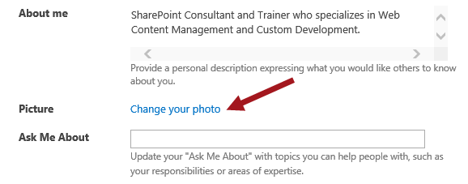

* 1. Outlook will open in a new browser window. On the right-hand side, click **Upload photo**.

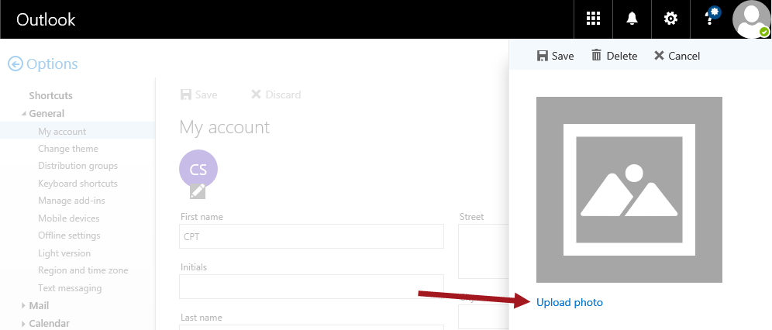

* 1. Browse for a photo you want to use as your profile photo, then click **Open**.

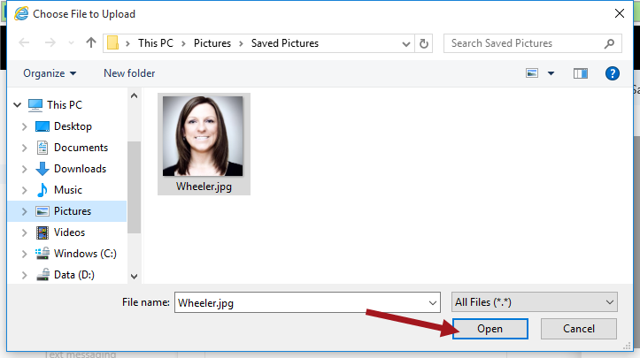

* 1. Notice the picture is uploaded and the photo is displayed. Click **Save**.

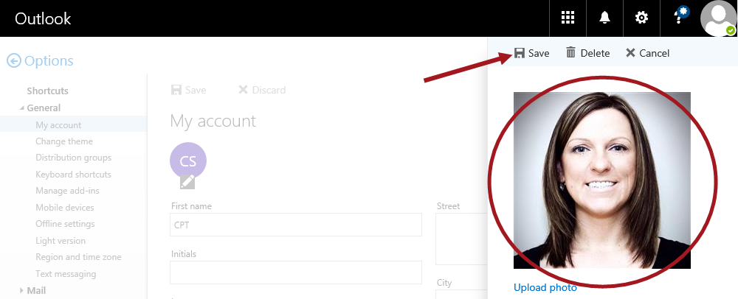

* 1. Notice your photo now shows up as a small round thumbnail. Now click the **X** to close the Outlook browser window.

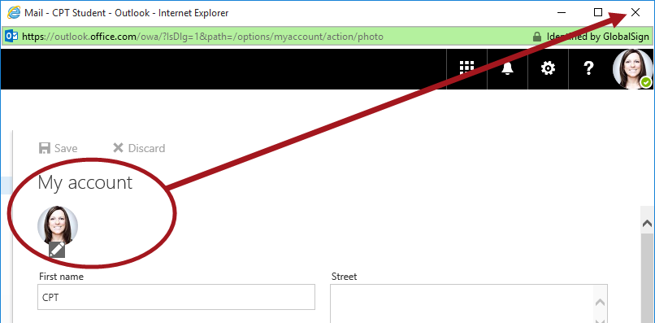

1. Go back to the other browser window. In the **Ask Me About** text box, type some topics such as **Workflows; InfoPath; SharePoint Designer** and then click the **Save all and close** button.

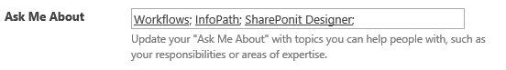

Continue with the next steps to update your contact information.

#### Edit Contact Information

1. Click the **Contact Information** link.

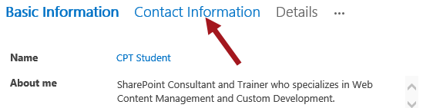

1. In the **Mobile** **phone** text box, type in a fake phone number.

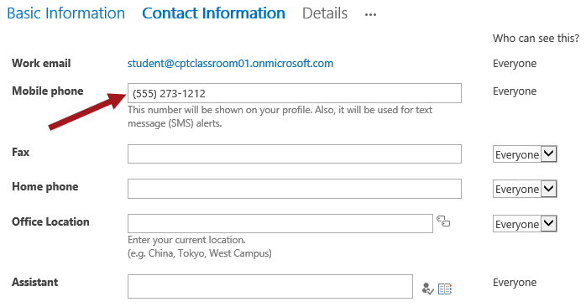

Set any other desired values and then continue with the next steps to update your Details.

#### Edit Personal Details

1. Click the **Details** link.

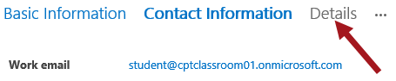

1. Update the values for the desired properties.

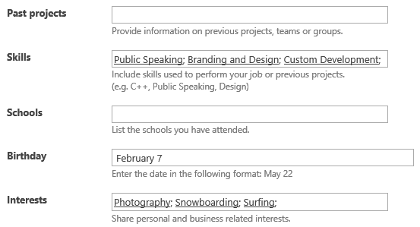

Continue with the next steps to update your Newsfeed settings.

#### Update Newsfeed Settings

1. Click the **ellipse (…)** and select **Newsfeed Settings**.

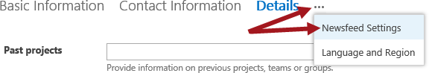

1. In the **Followed #Tags** text box, type any desired tags such as **#delve;#workflow;#sharepoint**.

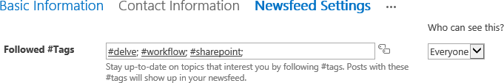

The **Who can see this?** drop-downs allows you to set the privacy. The default for most is set to Everyone however you can update based on you desired setting. Also, some values you see in your learning environment profile could be different in your profile within your organization if the administrator has made customizations to the global profile settings.

1. In the **Email Notifications** section, deselect any desired options you want to disable.

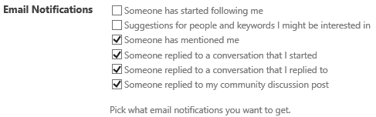

1. Update the **People I follow** and the **Activities I want to share in my newsfeed** as desired.

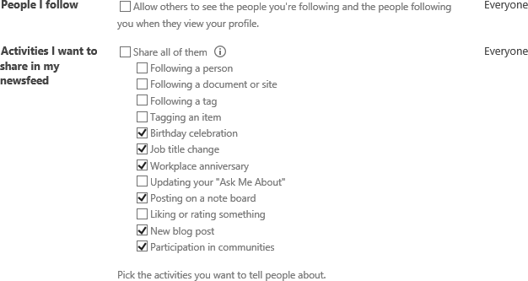

1. Once all desired updates are complete, click **Save all and close**.



1. From the **Profile Changes** dialog, click **OK**.

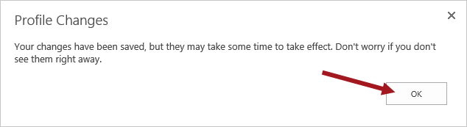

1. You’ll be redirected back to your profile page in Delve. Notice information you updated in your profile now shows up on the page.

Your profile photo may not show up immediately on your profile page because it could take time for Outlook to sync your profile photo updates to O365. Eventually your profile photo will show up on your profile page.

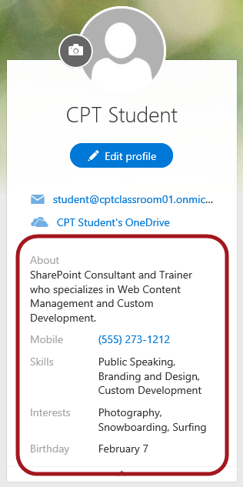

### Exercise 2: Create and Manage a Blog

In this exercise you will learn how to create a personal blog post.

#### Create a Blog Post

1. Make sure you are still on your profile page. If you’re not on your profile page anymore, go to your profile by doing one of the following:
   1. Click your profile picture in the Office 365 header, and then select **About me**.
   2. Or from the **App Launcher**, click on the Delve tile then click on from located in the left-hand menu.
2. Scroll to the Blog section on your profile and click **+** **New post**.

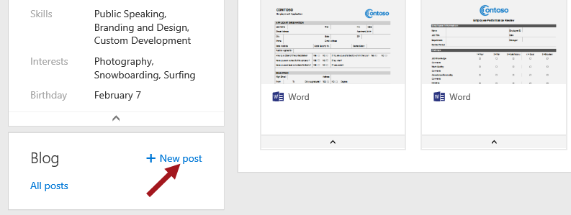

1. You should now see a page similar to the image below.

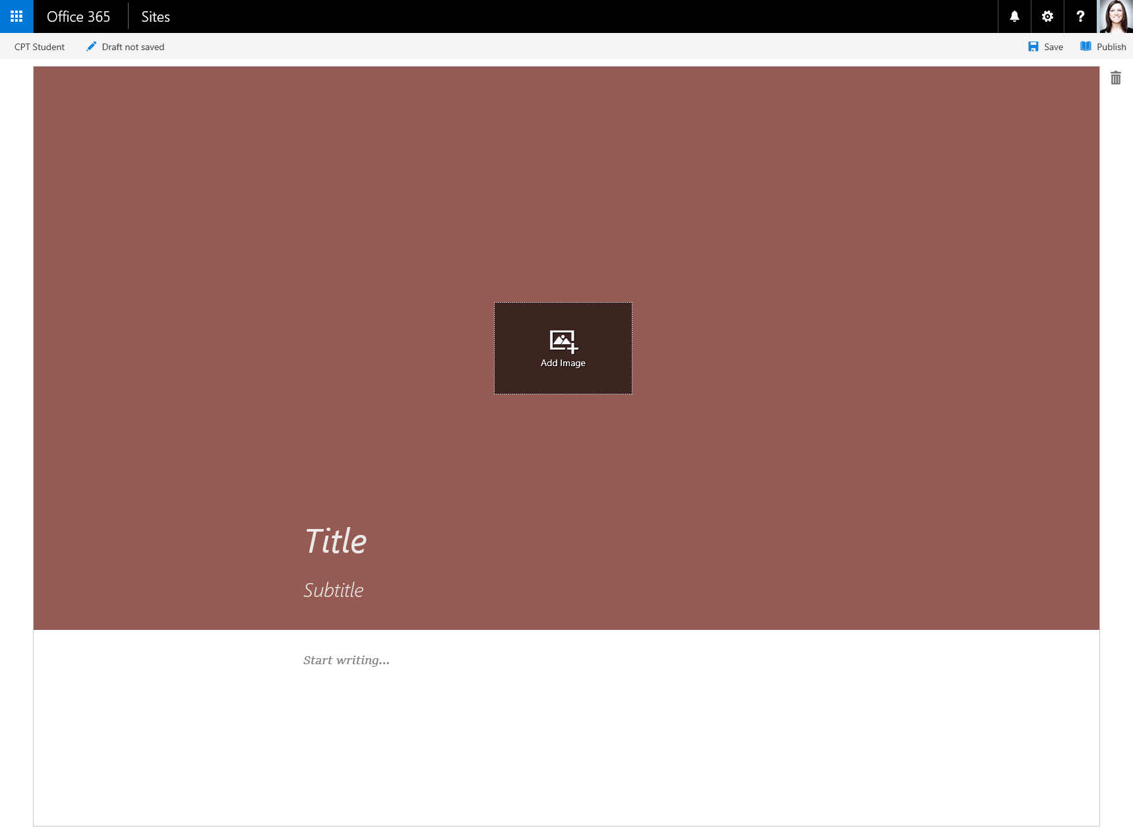

1. Click **Add Image** to add a header graphic for your blog post.

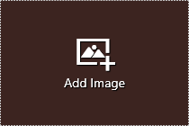

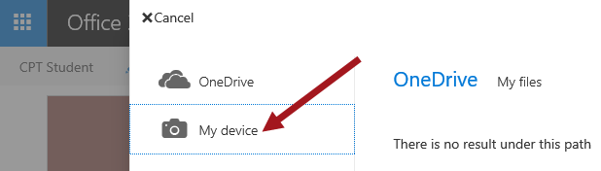

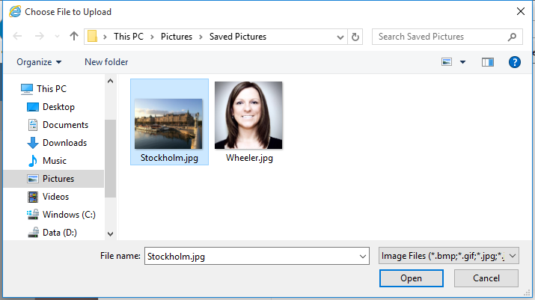

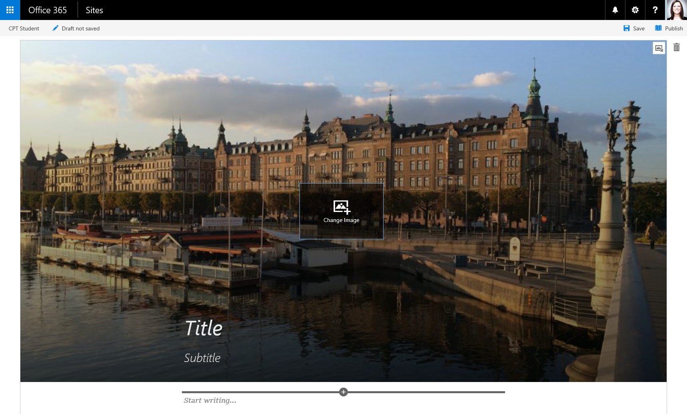

1. Click **Title** to add a title for your blog post and click **Subtitle** to add a subtitle if needed.



1. To add text to your blog post, click **Start writing** and enter the text for your blog post.

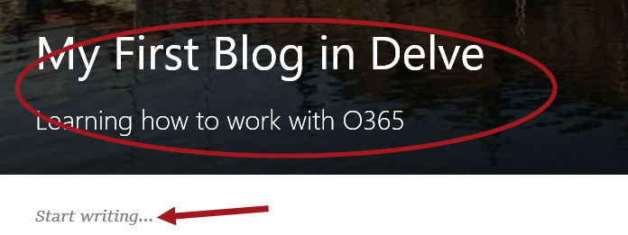

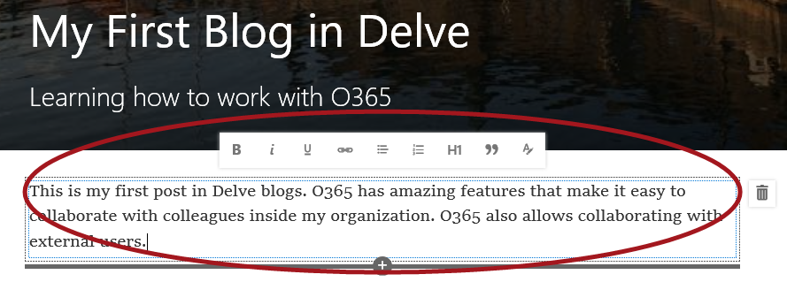

You can add an image, text area, video, or other asset to your blog post by hovering your pointer just above or below the text box, clicking the "+" sign that appears, and choosing the asset you want to add. When you add a document this way, the document appears as a thumbnail that is linked to the document. Clicking on the document opens it in Microsoft Office Online. You can also convert the asset to embedded view by clicking the expand arrows in the top right corner of the asset.

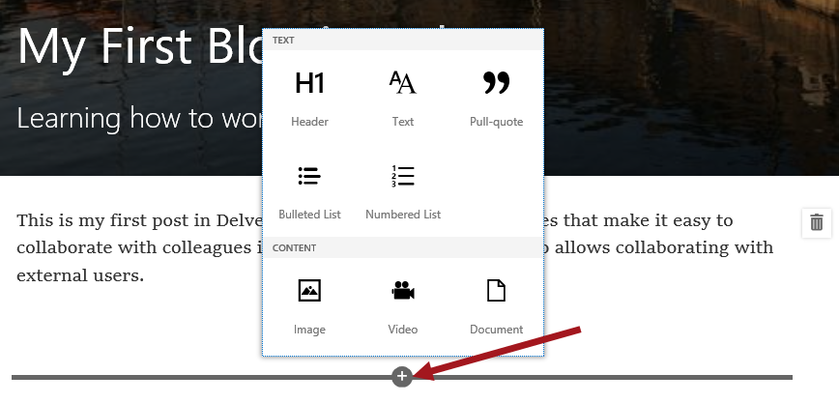

1. Once you are done writing content, you can publish your post by clicking **Publish** located in the upper-right hand side.



1. Once your post is published, it will be available in your **All posts** page.

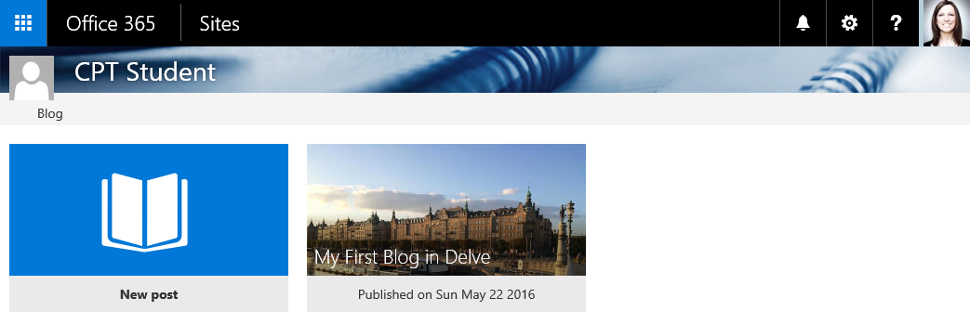

### Exercise 3: Post to Newsfeed

In this exercise you will learn how to post a newsfeed to everyone and add pictures, videos, links, and tags to a newsfeed post.

#### Create Newsfeed Post for Everyone

You can start conversations with people in your organization by posting to a newsfeed, either on your personal site or in team site newsfeeds. In this step, you will post a newsfeed on your personal site.

1. Click on the logged in user name **John Doe** located to the left of the **Settings** icon and select **About Me**.

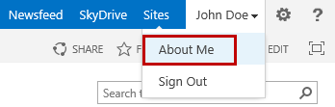

1. From the **About John Doe** page in the left navigation, click **Newsfeed**.

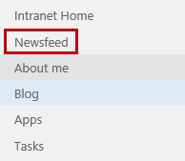

1. To start a conversation, click in the **Start a conversation** box.

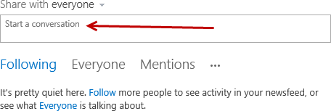

1. Similar to posting on a Facebook wall, start typing your message and then click **Post**.

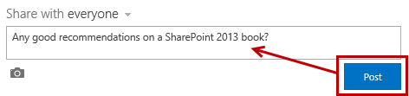

1. Once posted, the new conversation will show up in the **Newsfeed** and in the **About Me John Doe’s Activity** feed. Users can then **Like** or **Reply** to your post just like they can on Facebook wall posts. You can also reply to your own post just by clicking on **Reply**.

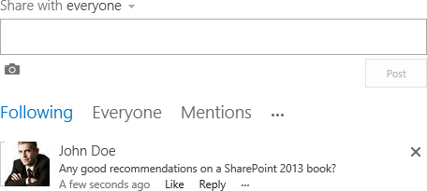

#### Add Picture to a Newsfeed Post

1. Click in the **Start a conversation** box
2. Click on the **picture** icon below the box.

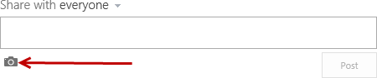

1. From the **Choose a picture** dialog, click **Browse**.

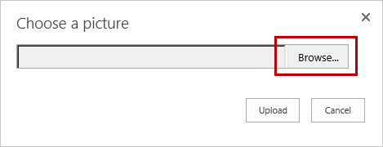

1. Navigate to **C:/Student/Social**. Click on the **NewsfeedPhoto.jpg** file and then click **Open**.

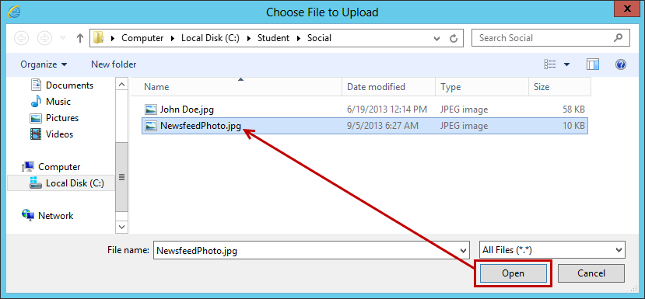

1. From the **Choose a picture** dialog, click **Upload**.

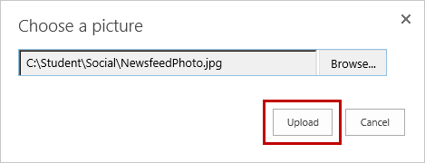

1. Add text to the conversation if desired and then click **Post**.

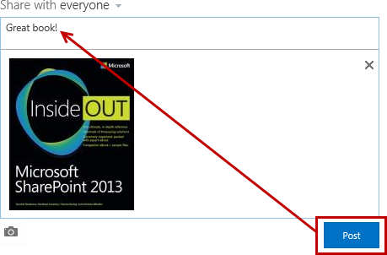

1. Notice the conversation is now posted to the Newsfeed wall.

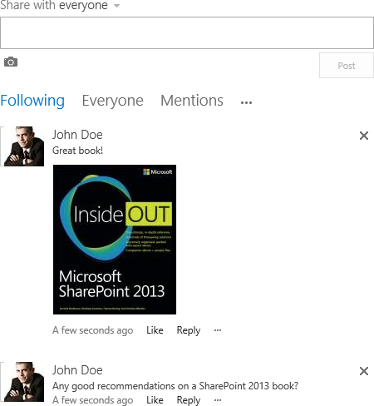

#### Add Website or Video Link to Newsfeed Post

1. Click in the **Start a conversation** box.
2. Just like posting a link on a Facebook wall, either **type** the web address or **paste** a copied address into the multi-line text box.

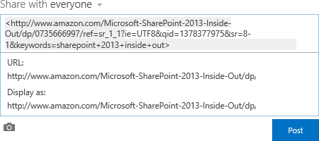

1. Click in the **Display as** box. Type the words you want to appear as the web link and then click the **check mark**.

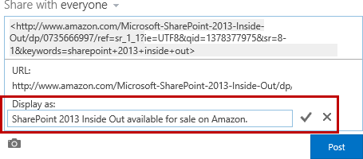

1. The post will preview with the URL and updated Display as text. Make additional changes if desired and when finished, click **Post**.

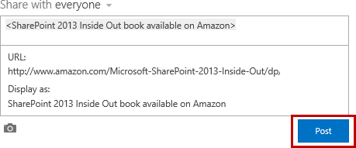

1. The link is now posted.

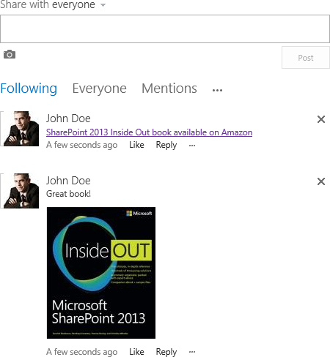

#### Add Document Link to Newsfeed Post

1. Navigate to the SharePoint library that has the document you want to post on the Newsfeed.

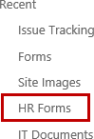

1. Click the **ellipse (..)** menu to open the document callout.



1. Select the document **URL**, right-click and select **Copy**.

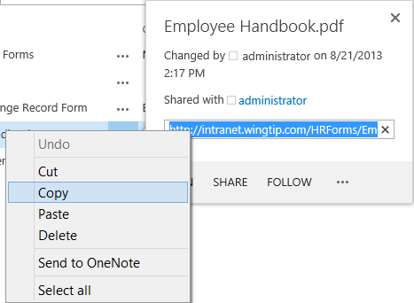

1. Click **Newsfeed** at the top of the page (or go to the team site newsfeed you want to post).



1. Click in the **Start a conversation** box.
2. Right-click and paste the document **URL**.

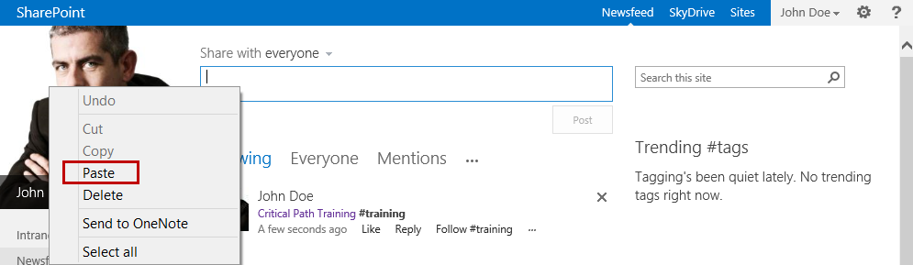

1. Click on the pasted web link to show the **URL** and **Display** **as** for the link.
2. Click in the **Display as** box. Type the words you want to appear as the document link and then click the **check mark**.

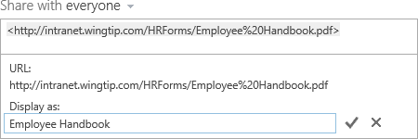

1. Click **Post**.
2. The link to the document is now in the Newsfeed.



#### Add Tags and Mentions to Newsfeed Post

1. Place your cursor in the **Start a conversation** multi-line text box.
2. Type the desired text for the conversation and then add tags to the text such as #training or a tag(s) pertaining to your conversation.

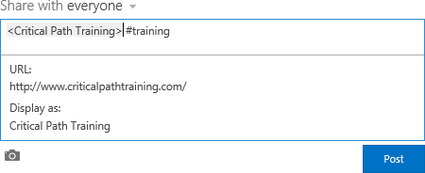

1. Once complete, click **Post**.



1. Click **Follow #training** to follow the hashtag.
2. Click on **#training** in the conversation post to the open the #training hashtag profile page.

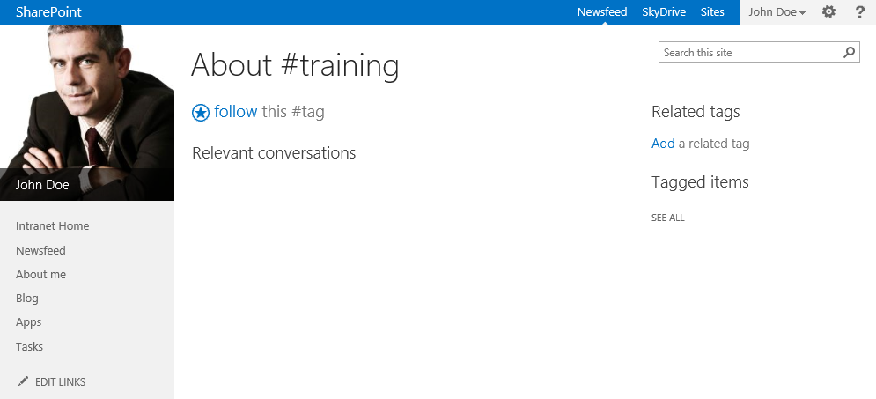

1. If you not did not click **follow** in step 21, you can also follow by clicking on **follow this #tag** from the #training hashtag profile page.

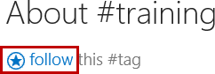

#### Delete a Conversation Post

1. Find the post you want to delete on your **Newsfeed**.
2. Hover your mouse to the right of the post and then click the **X** to delete.



1. From the **Get rid of this conversation** dialog, click **Delete** **it**.

### Exercise 4: Use a Team Site Newsfeed

Sometimes conversations are better suited for a small group of people instead of being on your personal site. In these cases it is best to create and follow a team site that contains its own newsfeed. You can also post to existing Team Sites if you have the appropriate permissions. In this exercise you post a conversation on the Wingtip Intranet Newsfeed and follow the team site.

#### Post a Feed on Team Site

1. Navigate back to the Wingtip Intranet home page. <http://intranet.wingtip.com>
2. Just like the steps you did in the previous exercise, click **Start a conversation** and then start typing your message.
3. Post a web link, document link, or a text conversation.

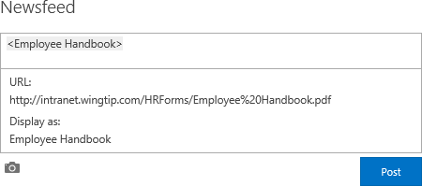

1. Once complete, click **Post**.

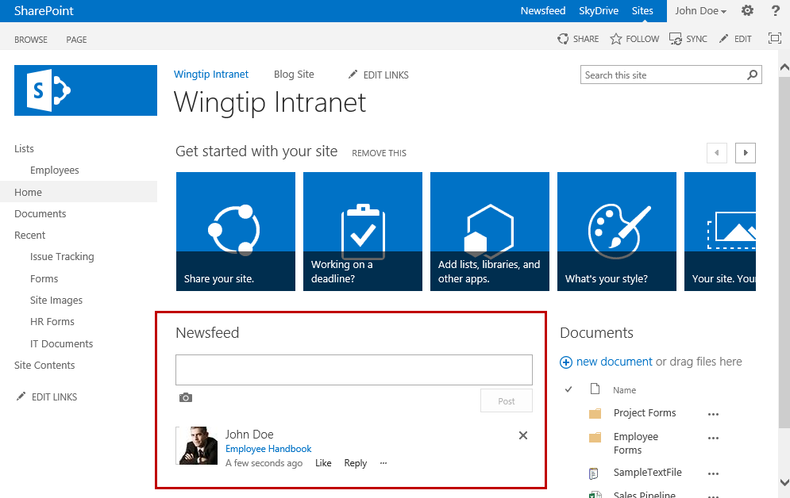

#### Follow and Unfollow Team Site

1. Navigate to the site you want to follow.
2. At the top of the page, click **FOLLOW**.

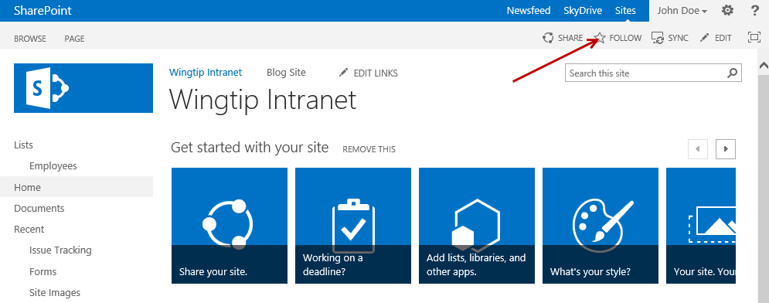

1. A notification will display the site name and the message **Now following this site**. This notification will disappear automatically.

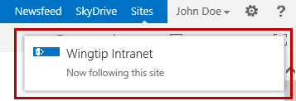

1. If you click on **FOLLOW** again a notification will display saying you are already following the site.

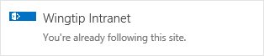

1. To Unfollow a Team Site:
   1. Click on **Newsfeed** located at the top of the page.
   2. Under **I’m following**, click on the **number** (ie. 2) for **sites**.

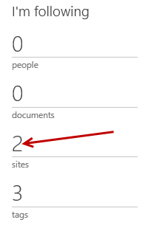

* 1. From the **Sites I’m following** page, find the site you want to unfollow and click **Stop following**.

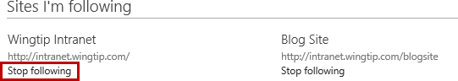

### Exercise 5: Working with OneDrive for Business

In this exercise you will learn to sync your OneDrive for Business library to your local computer, sync a site library to your computer, and work with files in a synced SharePoint library.

#### Sync OneDrive for Business Library to Computer

1. Navigate to your OneDrive for Business library by clicking in **SkyDrive** at the top of the page.



1. Click **SYNC** located at the top of the page.

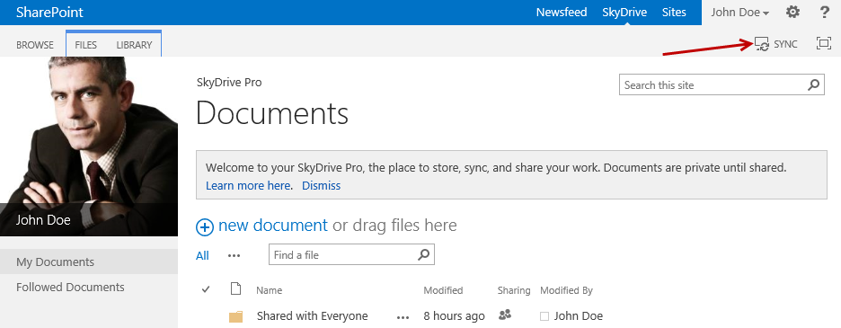

1. In the OneDrive for Business wizard, click **Sync Now**.

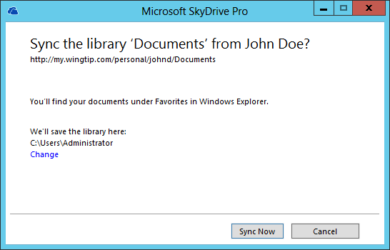

1. Wait for the sync to finish.
2. Click **Show my files…**

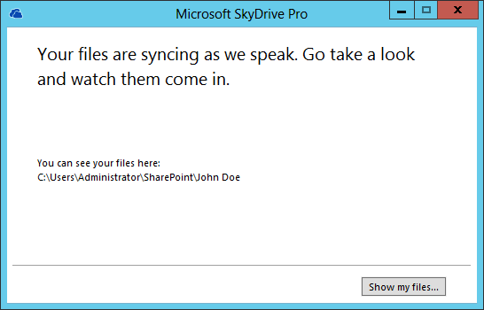

1. The Files Explorer automatically opens and displays your synced library.

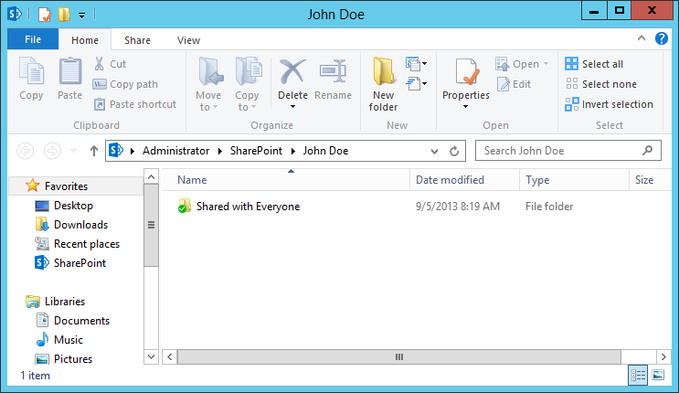

1. Click **Show My Files** to go to the synced library folder.

#### Sync Team Site Library to Computer

1. Navigate to the Team Site library you want to sync such as **IT Documents** located at the Wingtip Intranet root site.
2. Click the **SYNC** button at the top of the page.

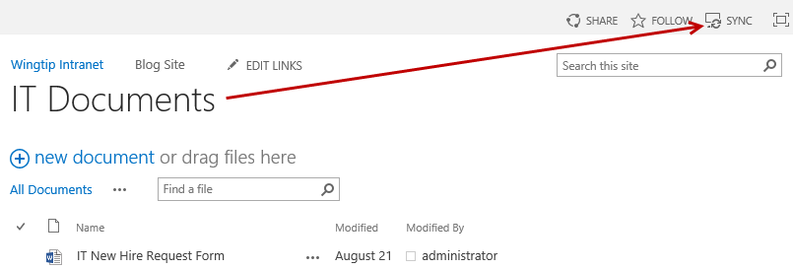

1. From the **Microsoft OneDrive for Business** library sync dialog, click **Sync Now**.
2. If prompted for credentials, enter the credentials supplied at the beginning of this lab.

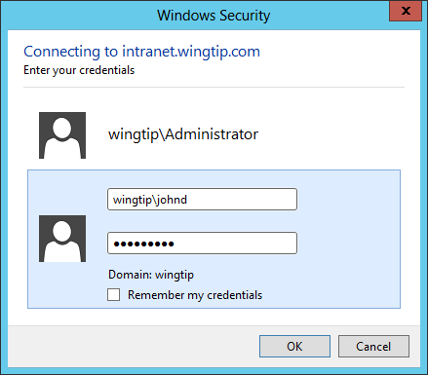

1. In the **Microsoft OneDrive for Business** dialog, select **IT Documents** from the **Select the library you want to sync** list and then click **Sync** **selected**.

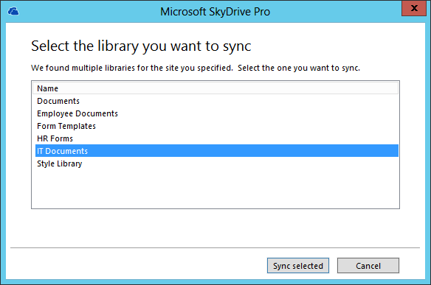

1. In the next dialog, click **Show my files…**

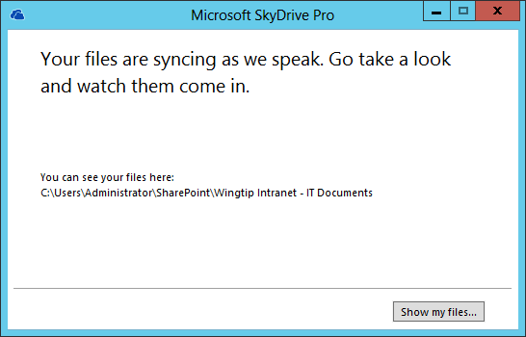

1. The **IT Documents** library is now synced to your local computer.

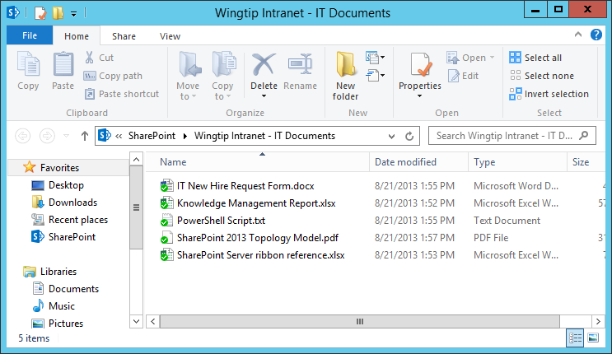

#### Work with Synced Files

1. Open the synced library folder in your file system.
2. Double-click on the **OneDrive for Business** icon in the Window’s taskbar.

**Note:** Team site library folders are placed under Favorites in the SharePoint folder. You can navigate to the synced folders directly through File Explorer or by double-clicking on the OneDrive for Business taskbar icon.

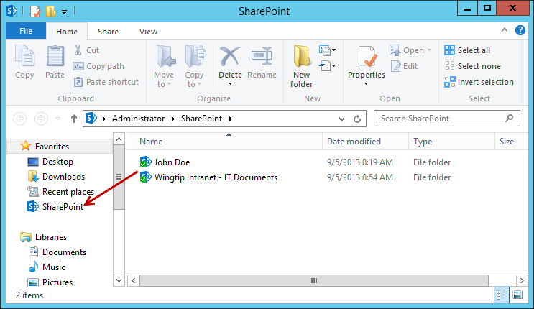

1. Right-click on a file or folder. Click **OneDrive for Business** and then click one of the available menu options:
   1. Select **Go to Browser** to see the selected file or folder on the SharePoint site in the browser.
   2. Select **Copy link** to copy the file’s Web URL in order to paste the link in another location such as an email.
   3. Select **Share…** to open the **Share** dialog box on the SharePoint site to send an invitation to share the file with other people.

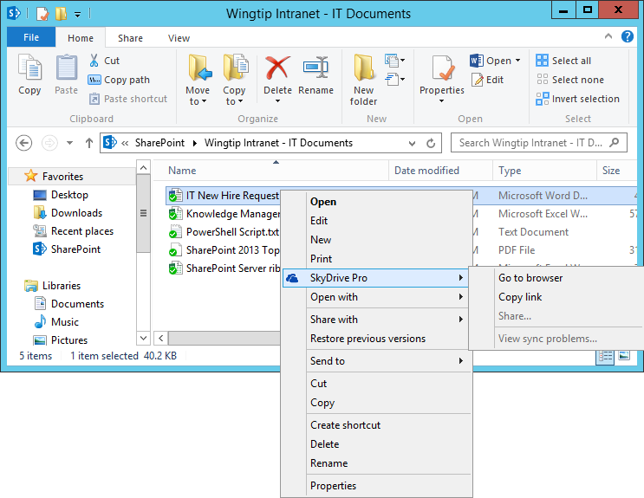

#### Stop Syncing a Library with OneDrive for Business

1. Click the **OneDrive for Business** icon in the Window’s taskbar and select **Stop syncing a folder…**

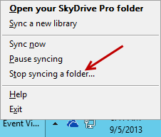

1. Select the folder you want to stop syncing, and then click **Stop syncing**.

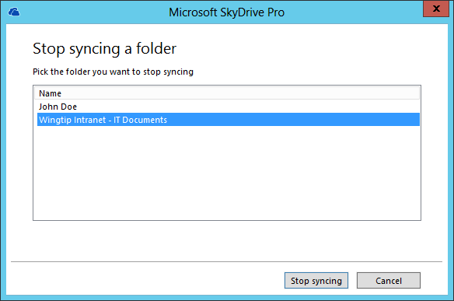

You have now completed this lab exercise.